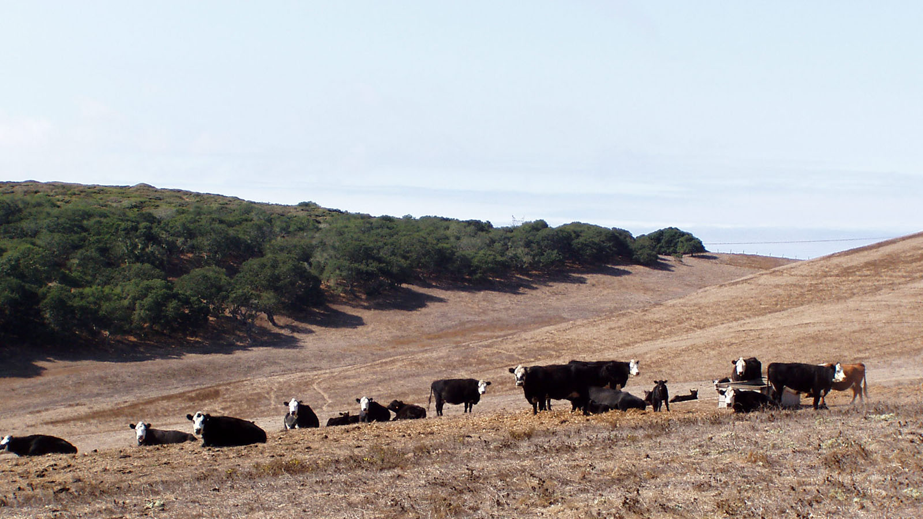

Livestock & Range Symposium
Santa Barbara County
Far Western Tavern, Orcutt
November 8, 2018

Welcome
Matthew Shapero
UC Cooperative Extension Livestock & Range advisor

“Trace mineral supplementation in beef cattle”
Dr. Gabriele Maier, Ph.D.
UCCE Specialist in Beef Veterinary Medicine

“What’s new in beef cattle genetics?”
Dr. Alison Van Eenennaam, Ph.D.
UCCE Specialist in Animal Genomics and Biotechnology

BREAK

“Developing an integrated pest management plan for controlling ground squirrels”
Roger Baldwin, Ph.D.
UCCE Specialist in Wildlife, Fish, and Conservation Biology

“Clean water, healthy soils, and productive ranches”
Dr. Ken Tate, Ph.D.
UC Davis Professor and UCCE Specialist in Rangeland Watershed Sciences

Closing Remarks

DINNER

