

Volume 13 No. 3

**FARM ADVISORS AND SPECIALISTS**

**Mary Bianchi** – Horticulture, San Luis Obispo

Phone: (805) 781-5949

Email to: [mlbianchi@ucdavis.edu](mailto:mlbianchi@ucdavis.edu)

Website: <http://cesanluisobispo.ucdavis.edu>

**Akif Eskalen** – Subtropical Extension Pathologist

UC Riverside

Phone: (951) 827-3499

Email: [akif.eskalen@ucr.edu](mailto:akif.eskalen@ucr.edu)

Website: <http://facultydirectory.ucr.edu>

**Ben Faber** – Subtropical Horticulture, Ventura/Santa Barbara

Phone: (805) 645-1462

Email to: [bafaber@ucdavis.edu](mailto:bafaber@ucdavis.edu)

Website: <http://ceventura.ucdavis.edu>

**Elizabeth Fichtner** – Orchard Systems, Tulare

Phone: (559) 684-3310

Email: [ejfichtner@ucanr.edu](mailto:ejfichtner@ucanr.edu)

Website: <http://cetulare.ucanr.edu>

**Craig Kallsen** – Subtropical Horticulture & Pistachio, Kern

Phone: (661) 868-6221

Email to: [cekallsen@ucdavis.edu](mailto:cekallsen@ucdavis.edu)

Website: <http://cekern.ucdavis.edu>

**Sonia Rios** – Subtropical Horticulture, Riverside/San Diego

Phone: (951) 683-8718

Email to: [sirios@ucanr.edu](mailto:sirios@ucanr.edu)

Website: <http://cesandiego.ucanr.edu>

**Eta Takele** – Area Ag Economics Advisor

Phone: (951) 683-6491 ext 243

Email to: [ettakele@ucdavis.edu](mailto:ettakele@ucdavis.edu)

Website: <http://ceriverside.ucdavis.edu>

**IN THIS ISSUE:**

**INTRODUCTION AND NEW RESEARCH**

* Predicting Water Demand Along the Coast Versus in the Valley
* Avocado Farm Families Still Healing, More Than a Decade Later: What Lessons Have We Learned About Fire Readiness and Prevention?
* Olive oil chemistry – Let’s talk about quality

**Announcements**

* Breakfast IPM Meeting: Citrus IPM and Chlorpyrifos Regulatory Update
* Macadamia Association Annual Field Day

**AUTHORS IN THIS ISSUE**

Gary Bender, Emeritus, University of California Cooperative, Extension, San Diego County

Ben Faber, University of California Cooperative Extension, Ventura/Santa Barbra Counties

Henry Herrera, CAL FIRE, San Bernardino, Inyo, and Mono Counties

Sonia Rios, University of California Cooperative Extension, Riverside/San Diego County

Selina Wang PhD, Research Director, UC Davis

*Editor’s Note: Please let us know if there are specific topics that you would like addressed in subtropical crop production. Phone or email the advisor in your county.*

**Sonia Rios**

**Fall 2015 Editor**

Craig Kallsen, Summer 2015 Editor

Topics In Subtropics - Fall 2015 – Published Quarterly

UCCE Riverside, 21150 Box Springs Road Ste. 202, Moreno Valley, CA 92557 • Phone (951) 683-6491 • Fax (951) 788-2615

• http://ceriverside.ucanr.edu/

U.S. Department of Agriculture, University of California, and Riverside County Cooperating

Fall 2015

**Predicting Water Demand Along the Coast Versus in the Valley**

Ben Faber, University of California Cooperative Extension, Ventura/Santa Barbra Counties

Recently I was asked why an irrigation schedule could be projected for almond and citrus in the Central Valley (Almonds:http://cekern.ucanr.edu/Irrigation_Management/Almond_Drip_-_Microsprinkler__Flood_Weekly_ET/Citrus: [http://cekern.ucanr.edu/Irrigation_Management/Citrus_ET_by_age/](https://owa.ucdavis.edu/owa/redir.aspx?SURL=74gFCXRjXuh2dZdTd24NwMEP4DJ0DQ1p_aBIX1fqKAdIWdQN8JnSCGgAdAB0AHAAOgAvAC8AYwBlAGsAZQByAG4ALgB1AGMAYQBuAHIALgBlAGQAdQAvAEkAcgByAGkAZwBhAHQAaQBvAG4AXwBNAGEAbgBhAGcAZQBtAGUAbgB0AC8AQwBpAHQAcgB1AHMAXwBFAFQAXwBiAHkAXwBhAGcAZQAvAA..&URL=http%3a%2f%2fcekern.ucanr.edu%2fIrrigation_Management%2fCitrus_ET_by_age%2f) ) and why the same couldn't be done for the main avocado growing areas. Here was my response:

Generating a generic irrigation schedule for avocados along the coast is very difficult and if done would be terribly misleading. Scheduling gets really hairy along the coast where avocados are grown. As you get further from the coast the water demand (ETo) increases in many months, typically increasing in the summer. This can be most pronounced in the late winter/spring when the fog along the coast really causes a contrast between coastal and inland conditions. May in Ventura, the sun comes out for about 2 hours and in Fillmore 20 miles inland it may be 90 F at 4 PM. The fog is a major determinant for irrigation demand and it varies daily, monthly and year to year from Monterey to San Diego. So fog can throw off an irrigation schedule.

The next variable to area-wide scheduling is the topography where avocados are grown, usually slopes to improve air and water drainage. Depending on the aspect and slope position, the ETo can vary tremendously depending on the sky conditions and what those conditions are depending on the time of day (such as foggy in the morning and clear in the afternoon). So west and south facing will always be higher than north and east. The top of the slope that intercepts more wind than the bottom and will have higher ETo than the bottom of the slope. And if the trees intercept more evaporative conditions midday when the sun comes out, it will be much higher than the east side in the morning when fog is dripping off the trees (zero evaporative demand). Then as you go south from Monterey to San Diego the ETo goes up, just because of latitude and sun interception. These conditions are very different from Fresno where ETo in July is 0.6 inches per day and is the same until Sept, the sky is clear most days and trees are grown on fairly flat ground.

Now throw in rainfall. Almonds are deciduous and only count on the value of rainfall as that which is stored in the rooting zone going into spring when leaves are come out. Avocados rely on winter rain for transpiration and salt leaching. In a good year a significant portion of the total yearly ETcrop can be subtracted from the irrigation demand. In a low/no rainfall year that all needs to be made up by supplemental irrigation.

An almond grower in the Valley might be able to go onto a calendar, set the clock if they have water on demand and walk away. That's never going to happen in a coastal avocado orchard. Depending on where the avocado is grown and the ETo at that site, applied water might vary from 1.5 ac-ft per acre to 3.5. This will depend on rainfall (when and how much), water quality (which determines leaching requirement) and the system delivery (system efficiency). This system issue can be further complicated by whether the delivery is on-demand or whether a certain amount will be delivered at a certain date for a certain length of time - 24 hours or 48. This makes it difficult for the grower to put on exactly what ETo and other issues the trees would demand. In this case, the delivery system determines the schedule.

So this is why there's no chart showing ET demand for coastal avocados where the bulk are grown in California.

**What Lessons Have We Learned About Fire Readiness and Prevention? Avocado Farm Families Still Healing, More Than a Decade Later**

Sonia Rios, Area Subtropical Horticulture Advisor, Riverside & San Diego Counties

Henry Herrera, Forester, California Department of Forestry and Fire Protection (CAL FIRE)

Gary Bender, Subtropical Horticulture Advisor, San Diego County

Many residents in Valley Center, Ramona, and Fallbrook, California can remember the magnitude of damage caused by the Cedar and Paradise Fires in 2003. On Sunday March 8th, 2015, NBC Dateline aired a two hour documentary on the Cedar and Paradise Fires as part of a special 3-part Escape Series about disaster survivors and how the affected communities are still healing: <http://www.nbc.com/dateline/video/dateline-escape-wildfires/2849489?onid=209511#vc209511=1>

NBC worked with CAL FIRE, San Diego Unit, to produce this documentary.

**Vegetation Weed Management**

Vegetation weed management is something CAL FIRE feels strongly about, especially during these times of drought. CAL FIRE interprets this type of weed management as a fuel reduction or fuel modification practice which helps growers create defensible space around their habitable structures or groves. Defensible space is a buffer between property (i.e. homes, groves, infrastructure) and plants (i.e. brush, trees, etc.) or other items surrounding the property to be protected that could catch fire and act as fuel.

Defensible space is needed to slow the spread of a wildfire and improves the safety of firefighters defending properties. Defensible space reduces the fire risk and creates space that firefighters can use as a tool to work safely and suppress a wildfire and to defend a structure or other property in the event of a wildfire. Fuel modification/reduction projects include defensible space around structures, fuelbreaks along roads and groves, ridge tops, or around property lines and other fire fuel reduction activities that lessen the risk of wildfires to communities. Fuel reduction projects usually remove cut vegetation from the site either through burning or haul-away methods. Fuel modification projects usually leave the cut vegetation on site in the form of wood chips or scattered material. These types of projects break up the lateral and horizontal vegetative continuity which result in reduced rates of fire spread, fire intensity, and flame heights which increase firefighter’s chances of suppressing fires.

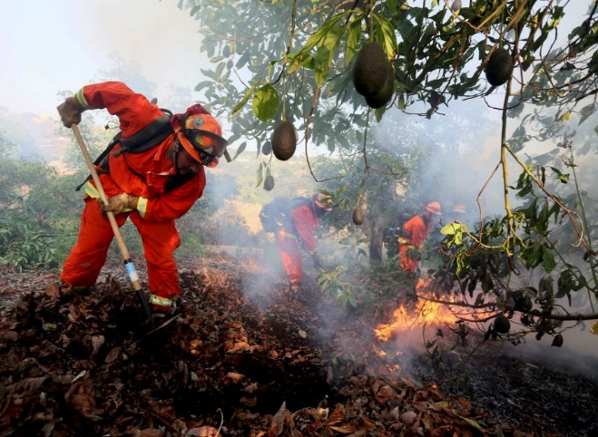

Photo 1: An inmate firefighter crew battles a fire in an avocado grove outside Fallbrook, California, May 14, 2014. Photo: Sandy Huffaker

Prunings piled in draws within or around the groves can also be particularly damaging because they are dried vegetation which pose an increased fire danger due to the fact that piles of vegetation can easily ignite and smolder for a long time creating a challenge to firefighters. Vegetation that is piled in draws or other waterways can also obstruct water flow during rain events which could lead to erosion and flooding.

**How to Keep our Growers and Groves Safe**

Preventative Measures:

These preventive measures can be suggested for groves in areas of high fire hazard are often counter to other measures which might reduce erosion or improve root disease control, so a balance should be strived for (Goodall 1965):

1. Remove all combustible material from around the trunks of the trees for a distance of two to three feet.

2. Prune off low-lying limbs, those that are low enough to accumulate more than the normal inch or so of leaf mulch.

3. Remove from the orchard all broken limbs, deadwood and other combustible debris.

4. Clear brush, trees and other heavy vegetation away from edge of orchard for a distance of at least 50 feet.

5. Do not pile brush or other combustible material in draws or canyons, or around the edges of groves.

6. Apply sprinkler water for as long a period in advance of the fire as possible so as to have everything wet. Water during the fire would obviously be desirable but often is lacking because of lack of pressure or speed of the movement of the fire.

7. Use steel pipe and risers for above ground sprinkler systems.

Growers can also look for other tips on preventive measures on the Cal Fire website: <http://calfire.ca.gov/fire_prevention/fire_prevention.php>.

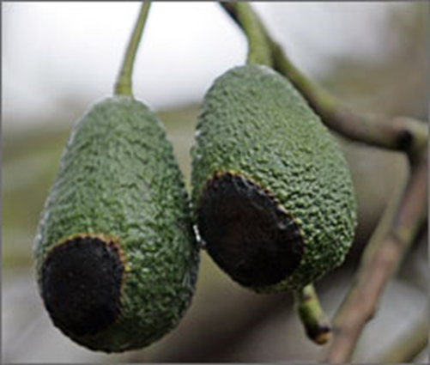

Photo 2: Low intensity fire damage on avocados. Photo: U.S. Today

**After a Fire**

It is nearly impossible to determine the extent of damage to the wood of the tree immediately after the fire. The most critical part of the tree is the main trunk. The bark from just above the ground to about two feet high can become hot enough to kill the cambium, the growth layer between the bark and wood. When the cambium is killed, the tree is girdled and will die (Goodall 1965). Suckers will eventually grow from below the graft union of these trees; these suckers can then be grafted to an appropriate variety. However, many trees in the grove may still be alive internally because there was a quick burn through the grove, or the leaves merely died from heat generated by burning surrounding trees, vegetation and mulch (Bender 2012).

According to Bender (2012), fire damaged trees that have leaves that are completely brown do not use water, but there may be trees that have escaped the fire in the irrigation block and these need to be irrigated as soon as possible. The first thing to do is to repair the irrigation system. Risers, sprinklers, pressure regulators and poly-hose on the ground are probably melted and should be replaced as soon as possible. PVC pipe that is buried underground is usually fine, depending on its depth and fire intensity. If part of the trees in the irrigation block are alive and partly damaged, it would probably be best to roll out poly-hose onto the damaged trees and set up a separate irrigation block. As the trees recover and start using water, you can eventually go back to the permanent system.

Trees that are heavily damaged do not use as much water (therefore transpiration is reduced significantly), but their feeder roots need to be watered and short irrigations should occur to replace water evaporating off of the soil surface. Start with a one hour irrigation and monitor the soil closely, irrigating too heavily could lead to the onset of root rot. Do not irrigate damaged trees on its original schedule; a ten hour irrigation will not “force” the trees to grow back sooner, and roots could be easily damaged by lack of oxygen in the lower soil profiles due to water accumulating and the soil becoming saturated.

Every fire is different, so experiences vary. It may take several months to be able to observe whether the bark is killed all the way to the cambium or not. Thus, we recommend against pruning until new growth appears to indicate where the wood is alive. According to Bender (2012), an alternative method which is rather unique to the avocado industry, the burned trees can all be stumped immediately and allowed to re-grow. “Stumping” is a normal practice in the industry when avocado trees have reached such heights that fruit is high off the ground and picking becomes difficult. In many of the groves that were burned, stumping was probably needed anyway; therefore after a burn stumping would be a reasonable alternative for many growers.

Fire damaged trees should be whitewashed on the south side of the limbs. Goodall (1965) also suggests to save expenses, fertilizer and pest control can be postponed for a year or so. Since the burned areas may be seeded by air and many weed seeds survive fires, a sprinkler irrigation will allow the ground cover to grow to minimize erosion the following winter. You may want to ground broadcast annual ryegrass, soft chess, or barley in critical areas before irrigating.

According to Bender (2012), if the goal of the grower is to bring trees back into production as soon as possible, the avocado tree will usually recover production faster if the grower is patient and prunes only the dead wood three months after the fire. Unfortunately, this practice creates a permanent problem in the grove as far as irrigation scheduling and application. Mixing full-grown trees (untouched by the fire) with partially pruned trees (and stumped trees) in an irrigation block means that some trees will be over-watered, or under-watered, depending on their size. Adjustments can be made in the sprinkler sizes, but generally this is an undesirable cultural practice due to every tree needing a different rate of irrigation and can this can also add to labor and equipment costs.

If the goal is to reduce the size of all trees in the irrigation block to a manageable size, then stumping the block immediately after the fire is the best solution. Trees will be out of production for two years and have about 50% production in the third year, and some re-grafting may have to be done, but fertilizing and watering properly is manageable.

A third option could be to scaffold all trees in an irrigation block to 12’ in height. This would get rid of a lot of dead wood immediately, and might allow the trees to come back in production faster than the stumping the trees.

It is helpful for growers to know the value, for insurance purposes, of trees that are lost due to fire. According to the Growing Avocados in Ventura County Reference Book, determining the value of a tree in an orchard is not a simple matter because one must take into account the income lost if the tree had been producing, as well as the costs of planting and maintaining the new tree. Also, the income from the new tree, once it comes into bearing, helps to defray the costs involved in bringing the tree to maturity. Examples can be seen here at the UCCE website: <http://ceventura.ucanr.edu/Agricultural_Threats/Fire_Information/>.

Record-low rainfall, extreme heat and a statewide drought has caused a significant increase in wildfires and a need for Californians to participate in fire-prevention tactics, including growers. According to CAL FIRE, in order to prevent wildfires and property damage, homeowners are asked to maintain “defensible space” around their house and groves year round and not use powered equipment outdoors when it’s hot, dry or windy. Wildfire prevention such as defensible space, keeping properties cleared of dried vegetation, and public education is the best long term solution.

[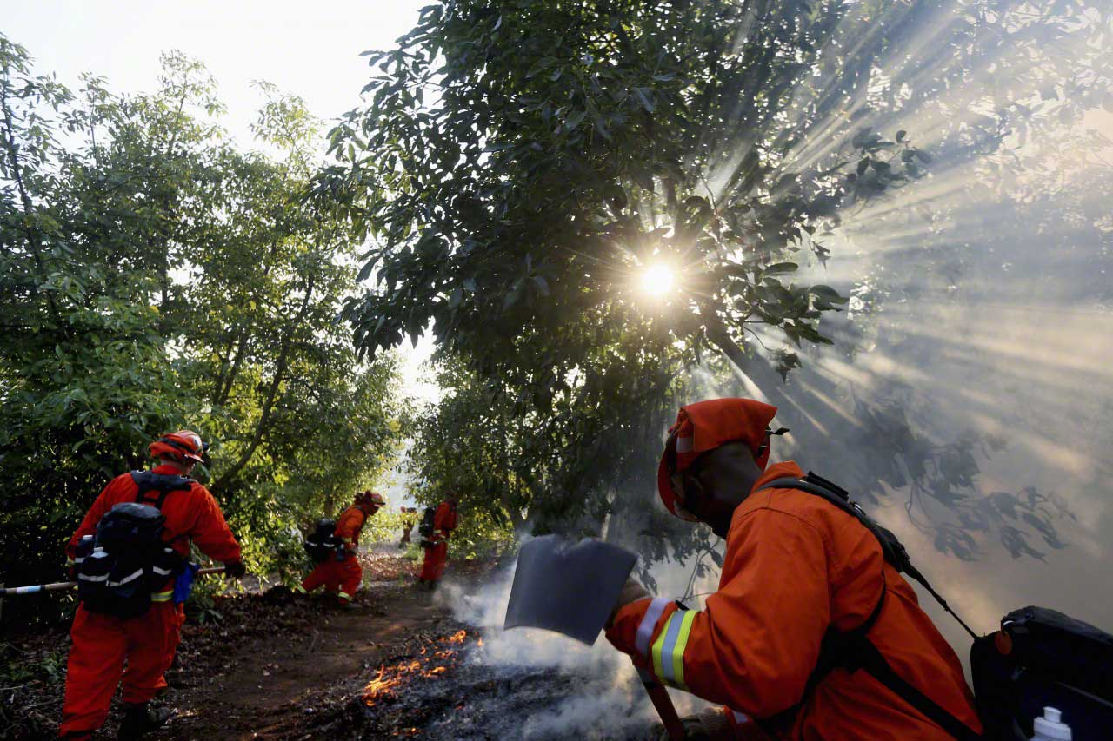](http://www.google.com/url?sa=i&rct=j&q=&esrc=s&source=images&cd=&cad=rja&uact=8&ved=0CAcQjRxqFQoTCKyN0J2shscCFUShgAodN9AM_Q&url=http://blog.corbis.com/portfolio/unforgettable-fire-photos-2014/&ei=6Oy7Vaz5M8TCggS3oLPoDw&bvm=bv.99261572,d.eXY&psig=AFQjCNEDYvj8iMe-7rXpmcyxbxB2_8AJKA&ust=1438465399183390)

Photo 3: A CAL FIRE inmate crew fighting a wildfire in an avocado grove, May 2014. Photo: Sandy Huffaker

**Work Cited**

Bender, Gary. 2012. Recovery from Fire Damage in Avocado Groves. UCCE San Diego Website: cesandiego.ucanr.edu/files/54279.doc. [Accessed June 16, 2015].

Goodall, G. E. Avocados and the Coyote Fire. California Avocado Society 1965 Yearbook 49: 81-83.

Ventura Co UCCE publication. Calculate Cost of Fire Damage to Avocado and Citrus Trees. Growing Avocados in Ventura County Reference Book. UCCE Ventura

**Olive Oil Chemistry-Let’s Talk About Quality**

Selina Wang PhD, Research Director, UC Davis

Edible oils are made up of mostly triacylglycerols, which are lipids that serve as an energy source for plants and animals. Oil that is produced from different plants or animals has its unique triacylglycerols compositions. Extra virgin olive oil (EVOO) is fresh juice from healthy olive fruits, extracted solely through mechanical means. In addition to the triacylglycerols, EVOO also contains free fatty acids, mono- and diacylglycerols, sterols, pigments, phenolics and volatile compounds.

In this article of the Topics in Subtropics Newsletter, we will cover the chemistry of olive oil quality in “Grades and Labeling Standards for Olive Oil, Refined-Olive Oil and Olive-Pomace Oil” which was approved by the California Department of Food and Agriculture (CDFA) and became effective in September 26, 2014. The standards are based on the scientific research at the UC Davis Olive Center and are the first in the world to require those who produce more than 5,000 gallons in California to test of every lot of oil.

**Free Fatty Acidity (FFA)**

The most abundant fatty acid in olive oil is oleic acid (C18:1). Fatty acids are part of the triacylglycerol molecule, however, they become “free” when the endogenous lipase enzymes are released. The level of FFA increases when fruits are damaged due to pests, disease, or freeze before harvesting, and improper fruit storage (hot, humid environment, long term) before processing. FFA does not change much under proper storage of the oil.

**Peroxide Value (PV)**

Peroxides value increases when oil gets oxidized. This can occur during oil extraction, processing, bottling and storage. Peroxides are primary oxidation products that lead to the formation of secondary oxidation products - important volatiles that are responsible for the deterioration of olive flavors. When oxidation advances, some peroxides are concerted secondary oxidation products and hence peroxide value is lowered. Therefore, peroxide value is useful when other chemical parameters and processing factors are taken into consideration. For example, measuring peroxide value at the point of production can help ensuring that the extraction and processing allow minimum oxidation to occur. Oxygen, light and high temperature speed up the oxidation process.

**Ultraviolet Absorbency (UV)**

Oxidation causes an increase of absorption in certain wavelengths in the UV region and increases the values of K232 and K268/K270 (depending on the solvent used). Refining also increases these values, so this test can be useful for detection of refined oils and oxidized/aged oil.

**Pyropheophytin *a* (PPP)**

Chlorophylls are naturally occurring pigments in olives that give oil the green hue. With time and heat, chlorophylls are converted to pheophytins and pyropheophytins. This chemical method measures the ratio of pyropheophytins *a* to the total pheophytins which can be useful to differentiate fresh oils from oils that have been stored for a long term, in high temperature, or refined.

**Diacylglycerols (DAGs)**

Diacylglycerol, a molecule that contains two fatty acids, form when one of the three fatty acids is lost in a triacylglycerol molecule. With time and heat, the two fatty acids can move from the 1, 2 position (resulting a 1, 2-diacylglycerol**)** to the 1, 3 position (resulting a 1, 3-diacylglycerol**)**. The ratio of 1, 2 and 1, 3-diacylglycerol can be used to differentiate fresh oils from old oil or oils that were made from damaged fruits.

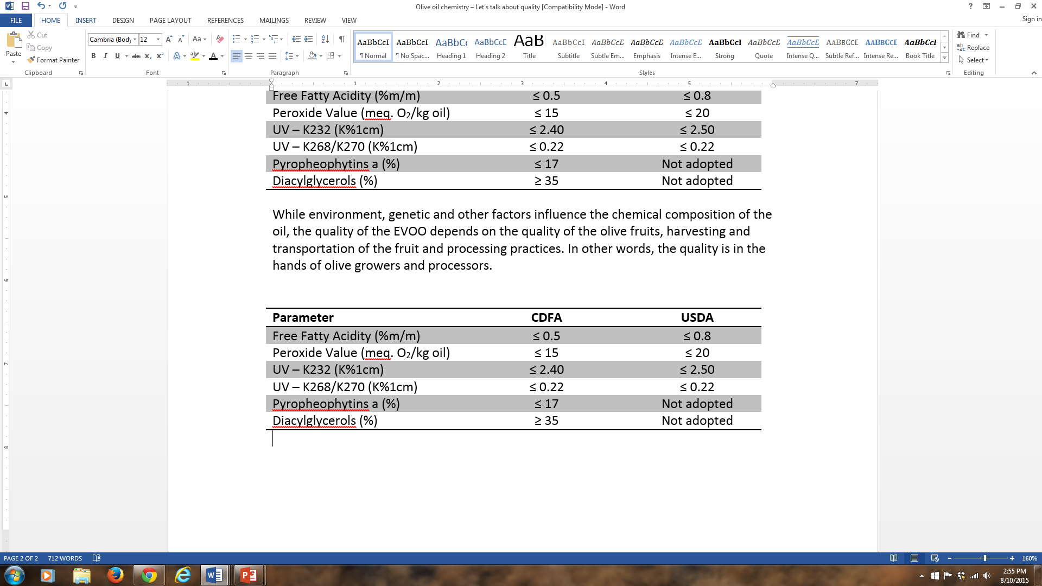The EVOO limits for each chemical parameter from the CDFA and the U.S. Department of Agriculture (USDA) are shown below.

While environment, genetic and other factors influence the chemical composition of the oil, the quality of the EVOO depends on the quality of the olive fruits, harvesting and transportation of the fruit and processing practices. In other words, the quality is in the hands of olive growers and processors.

**Announcements**

**Breakfast IPM Meeting: Citrus IPM and Chlorpyrifos Regulatory Update**

CDPR Continuing Education Units Applied for: 3.0 hours (1.0 Laws/ 2.0 Other)

* Free, no fee required.
* Meeting Runs 8:30 AM until Noon

Hot Breakfast Courtesy of Citrus Research Board.

Topics that will be discussed:

• Context of Chlorpyrifos in Local IPM

• Project Overview & Crop Team Process

• Definition of Critical Uses of Chlorpyrifos

• Decision Support Tools

• Hands-on Training

• Best Management Practices

• Citrus Pest Update

• Ant ID and Training

• Stewardship Principles in IPM

• Science Behind New Regulations

• Required Mitigation

• Local Restrictions on Chlorpyrifos

• Local on-Farm Stewardship

• Impact of Regulations on Decisions on IPM

San Diego Location: Sept. 15, 2015

8:00 AM – Noon

*Space is limited, please RSVP

<http://ucanr.edu/survey/survey.cfm?surveynumber=14651>

Hot Breakfast and Coffee at 8:00 AM

San Diego Farm Bureau

1670 E. Valley Pkwy

Escondido, CA 92027

Santa Paula Location: Sept 16, 2015

8:00 AM – Noon

Hot Breakfast and Coffee at 8:00 AM

Hansen Research and Extension Center

14292 W Telegraph Rd

Santa Paula, CA 93060

Tulare Location: January 12, 2016

TIME TBD

Lindcove Research and Extension Center

22963 Carson Avenue

****Exeter, CA 93221



**Macadamia Association Annual Field Day**

The University of California Cooperative Extension in conjunction with the California Macadamia Society and the Gold Crown Macadamia Association will hold their Annual Field Day on Saturday September 26, 2015, 8:45 A.M. to 1:30 P.M. at the home of Jim and Jane Zeimantz, 3410 Alta Vista Drive, Fallbrook, California.

This will be a great opportunity for all that are interested to learn about growing macadamia nuts in California. In addition to the commercial growers, macadamias make excellent back yard trees, are beautiful as landscaping, and can be grown in tubs on your patio. The macadamia is native to Australia and has been grown in California continuously since 1879.

There will be classes on topics relevant to the current macadamia industry, with plenty of opportunities for you to ask questions, both general in nature and about the specifics of your operations. We will also be serving a continental breakfast and a delicious lunch. Please plan to join us for a fun and information filled day.

Cost: $20.00 per person with pre-registration, $25.00 at the event. That includes a continental breakfast and delicious lunch.

Contact Person: Jim Russell, (760) 728-8081 e-mail russellfarms@Roadrunner.com

Visit www.macnuts.org/fieldday.htm for a registration form.

The California Macadamia Society has members all over the world.

**The Objectives of the California Macadamia Society are:**

* To furnish authoritative and timely information on Macadamia culture.
* To assist growers with harvesting and marketing data.
* To advise nurserymen on varieties and propagation.
* To encourage the University to assist the industry with research.
* To formulate policies, where indicated, for presentation to the state legislature.

**The Objectives of the California Macadamia Association are:**

* To assure a reliable market to our growers.
* To provide the highest return to our growers for nuts delivered.
* To explore new and developing markets for macadamia nuts.

**Directions:**

From I-5 take exit 54a (east) onto Ca-76, Pala Road. Go 13.5 miles and turn left (north) onto Via Monserate. Go 1.3 miles and turn right on Alta Vista Drive. Go 1 mile to 3410 Alta Vista Drive, on the right.

From I-15 take exit 46 (west) onto Ca-76, Pala Road. Go 3.4 miles and turn right (north) onto Via Monserate. Go 1.3 miles and turn right on Alta Vista Drive. Go 1 mile to 3410 Alta Vista Drive, on the right.

*Topics in Subtropics*



Disclaimer: The University of California prohibits discrimination or harassment of any person on the basis of race, color, national origin, religion, sex, gender identity, pregnancy (including childbirth, and medical conditions related to pregnancy or childbirth), physical or mental disability, medical condition (cancer-related or genetic characteristics), ancestry, marital status, age, sexual orientation, citizenship, or status as a covered veteran (covered veterans are special disabled veterans, recently separated veterans, Vietnam era veterans, or any other veterans who served on active duty during a war or in a campaign or expedition for which a campaign badge has been authorized) in any of its programs or activities. University policy is intended to be consistent with the provisions of applicable State and Federal laws. Inquiries regarding the University’s nondiscrimination policies may be directed to the Affirmative Action/Staff Personnel Services Director, University of California, Agriculture and Natural Resources, 1111 Franklin Street, 6th Floor, Oakland, CA 94607, (510) 987-0096. Discussion of research findings necessitates using trade names. This does not constitute product endorsement, nor does it suggest products not listed would not be suitable for use. Some research results included involve use of chemicals which are currently registered for use, or may involve use which would be considered out of label. These results are reported but are not a recommendation from the University of California for use. Consult the label and use it as the basis of all recommendations.

*Craig Kallsen, Citrus, Pistachios/Subtropical Horticulture Advisor*

*cekallsen@ucdavis.edu or 661-868-6221*