

**FARM ADVISORS AND SPECIALISTS**

**Mary Bianchi** – Horticulture, San Luis Obispo

Phone: (805) 781-5949

Email: mlbianchi@ucdavis.edu

Website: <http://cesanluisobispo.ucdavis.edu>

**Greg Douhan –** Area Citrus Advisor, Tulare, Fresno, Madera

Phone: 559-684-3312

Email: [gdouhan@ucanr.edu](mailto:gdouhan@ucanr.edu)

Website: <http://cetulare.ucanr.edu>

**Akif Eskalen** – Subtropical Extension Pathologist UC Riverside

Phone: (951) 827-3499

Email: akif.eskalen@ucr.edu

Website: <http://facultydirectory.ucr.edu>

**Ben Faber** – Subtropical Horticulture, Ventura/Santa Barbara

Phone: (805) 645-1462

Email: bafaber@ucdavis.edu

Website: <http://ceventura.ucdavis.edu>

**Elizabeth Fichtner** – Orchard Systems, Tulare

Phone: (559) 684-3310

Email: ejfichtner@ucanr.edu

Website: <http://cetulare.ucanr.edu>

**Craig Kallsen** – Subtropical Horticulture & Pistachio, Kern

Phone: (661) 868-6221

Email: cekallsen@ucdavis.edu

Website: <http://cekern.ucdavis.edu>

**Philippe Rolshausen –** Extension Specialist Subtropical Crops, UCR

Phone: (951) 827-6988

Email: [philippe.rolshausen@ucr.edu](mailto:philippe.rolshausen@ucr.edu)Website: http://ucanr.edu/sites/Rolshausen/

**Sonia Rios** – Subtropical Horticulture, Riverside/San Diego

Phone: (951) 683-8718

Email: sirios@ucanr.edu

Website: <http://cesandiego.ucanr.edu>

**Eta Takele** – Area Ag Economics Advisor

Phone: (951) 683-6491 ext 243

Email: ettakele@ucdavis.edu

Website: <http://ceriverside.ucdavis.edu>

**TOPICS IN THIS ISSUE:**

* “We Shall Defend our Citrus, We Shall Fight in Backyards and Community Gardens, We Shall Fight in Organic and Conventional Citrus Orchards; We Shall Never Surrender.”
* Organic Control of Asian Citrus Psyllid is Challenging
* Citrus Clonal Protection Program (CCPP) and National Clean Plant Network (NCPN): A Model System for Management of Citrus Diseases

* Discouraging citrus varieties smuggling by offering easy access to pathogen-tested budwood

*Subscribe and Read the Weekly Topics in Subtropics Blog at: <http://ucanr.edu/blogs/Topics/>

**AUTHORS**

Nastaran Tofangsazi, Post Doc, Department of Entomology, University of California, Riverside

Elizabeth E. Grafton-Cardwell, IPM Specialist with the Department of Entomology, University of California Riverside, and Director of Lindcove Research and Extension Center

Georgios Vidalakis, Department of Plant Pathology and Microbiology, University of California, Riverside

Greg W. Douhan University of California Cooperative Extension, Tulare County

Rock Christiano, Citrus Clonal Protection Program Lindcove Research & Extension Center, University of California, 22963 Carson Avenue, Exeter, CA  93221

Ben Faber, UCCE Farm Advisor, Ventura and Santa Barbara Counties

Greg Douhan

Editor

**Volume 14 No. 2 June 2016**



**“We Shall Defend our Citrus, We Shall Fight in Backyards and Community Gardens, We Shall Fight in Organic and Conventional Citrus Orchards; We Shall Never Surrender.”**

*Mark S. Hoddle, Extension Specialist in Biological Control, Department of Entomology,*

*University of California Riverside, CA 92521*

[mark.hoddle@ucr.edu](mailto:mark.hoddle@ucr.edu)

Well, what a dramatic title, and it is certainly an unabashed rip off from Winston Churchill too! However, many growers in California view the threat posed to the long term viability and profitability of citrus by Asian citrus psyllid (ACP) (Fig. 1) and huanglongbing (HLB) as a war! ACP is a small sap sucking insect that is native to the Indian subcontinent and it has emerged as a global threat to citrus because it vectors a bacterium (*Candidatus* Liberibacter asiaticus [*C*Las]) that causes a lethal and incurable citrus disease, huanglongbing (sometimes referred to as citrus greening). Trees displaying HLB go into decline and some varieties may die in as little as 5-8 years post-infection. Symptoms may include chlorotic leaves (Fig. 2) and premature fruit drop. Fruit that are retained become misshapen as they develop, ripen irregularly (hence the common name citrus greening), and have a bitter taste. Florida’s “war” with ACP and HLB started around 1998 when the psyllid was first found, then in 2005 the first citrus trees with HLB symptoms were discovered. Some economic estimates of the ACP-*C*Las epidemic in Florida suggest that more than 8,000 jobs have been lost, production has declined by 23%, and revenues have dropped by 16% (Hodges and Spreen 2012).

ACP was first detected in southern California in 2008, and in 2012, the first citrus trees with HLB symptoms were found in Hacienda Heights in Los Angeles County. Subsequently, HLB has been confirmed in San Gabriel, also in LA County. Detections of ACP in the San Joaquin Valley (SJV) are increasing, especially around Bakersfield, and these finds make the largest citrus production areas in California highly vulnerable to *C*Las. One response to the ACP invasion has been to go after the vector in urban residential areas where ACP enjoys a relatively good life on backyard citrus trees that are treated infrequently with pesticides (Kistner and Hoddle 2015a). The intention of this urban-residential-ACP control program was to knock back psyllid numbers to low levels with the goal of reducing the rate of spread of ACP and *C*Las through urban areas and into commercial citrus production zones. Vector reduction have been attempted in two different ways; spraying insecticides and biological control. The California Department of Food and Agriculture aggressively pursued residential spraying of citrus during the initial stages of the ACP campaign in southern California, but this quickly became unsustainable due to cost and the speed at which ACP was spreading through the urban landscape. Spraying is still used in areas were ACP populations are small and localized, such as those being found in parts of the SJV.

The second approach has been to run a classical biological control program targeting ACP. Classical biological control introduces natural enemies from the home range of the pest into the invaded area with the goal of establishing these beneficial agents so that they permanently suppress pest populations to less damaging levels. This approach necessitated searches for ACP natural enemies in the native range of the pest, a process referred to as foreign exploration. Because ACP has a huge putative native range, foreign exploration was conducted in Punjab Pakistan (Fig. 3), an area with ~70% climate match with the major citrus production areas in the SJV. A good climate match, in theory, should result in natural enemies that are pre-adapted to California’s hot dry summers and cool damp winters. From September 2010 to April 2013, six expeditions searching for ACP natural enemies were conducted in Pakistan. The University of Agriculture Faisalabad (UAF) was the home base for this project. Collaboration with UAF Faculty was excellent, and the Vice Chancellor of UAF, Dr. Iqrar Khan, is a UC Riverside graduate in plant pathology, and Mike Roose was Iqrar’s major professor!

Two species of parasitoid, *Tamarixia radiata* (Fig. 4) and *Diaphorencyrtus aligarhensis* (Fig. 5), were found attacking ACP in Pakistan. Both species were returned to the Insectary and Quarantine Facility at UC Riverside. Mandatory host range and host specificity tests were conducted over a 2-3 year period and results indicated that both species likely posed little environmental risk to California and it was concluded that both species offered significant benefits because of their ability to parasitize and feed on ACP nymphs. Both of these processes kill ACP nymphs. Consequently, USDA-APHIS issued release permits and CDFA took over the mass rearing of these parasitoids. As of June 2016, more than 3 million *Tamarixia* and 170,000 *Diaphorencyrtus* have been released in southern California.

Initial results of the ACP biocontrol program are promising. *Tamarixia* appears to have established widely in southern California (Hoddle et al. 2016), and in combination with other species of natural enemies, especially generalist predators like lacewing and syrphid fly larvae, significant reductions in ACP populations have been documented (Kistner and Hoddle 2015a,b,c; Kistner et al., 2016). *Diaphorencyrtus* lags behind *Tamarixia* because it was the second parasitoid out of the quarantine pipeline, but multiple recoveries have been made at about 60% of sites where this species has been released. However, the impact and rate of spread of *Diaphorencyrtus* and whether it can compete successfully with *Tamarixia* is unknown and the subject of Citrus Research Board (CRB) and USDA-MAC sponsored research (see Vankosky and Hoddle 2016 for more information on *Diaphorencyrtus*).

Although the major biocontrol efforts have centered on ACP in residential areas in southern California, the focus of the biocontrol program, especially with respect to *Tamarixia*, is beginning to face northwards, and battle lines are being drawn around and through Bakersfield and Tulare. The redirection of effort has been the subject of intense discussion at recent CRB BioControl Taskforce meetings (Hoddle et al., 2016). The emerging consensus is that movement of biocontrol agents into urban areas north of the Tehachapi mountains is needed. It is highly likely that in late 2016 or early 2017 Pakistani mercenaries will be released for the first time into the SJV to hunt down ACP.

**References Cited:**

Hoddle, M.S., R. Amrich, C.D. Hoddle, and E.J. Kistner. 2016. Where’s Tamarixia? Citrograph 7:   
(3) 64-66.

Hodges, A.W. and T.H. Spreen. 2012. Economic impacts of citrus greening (HLB) in Florida, 2006/07 – 2010/11. <http://www.crec.ifas.ufl.edu/extension/greening/PDF/FE90300.pdf> (last accessed   
17 June 2016).

Kistner, E.J. and M.S. Hoddle. 2015a. Life of ACP. Citrograph 6(2): 52-57.

Kistner, E.J. and M.S. Hoddle. 2015b. Biological control of the Asian citrus psyllid shows promise in southern California’s residential landscapes. CAPCA Adviser 18(2): 50-54.

Kistner, E.J., R. Amrich, M. Castillo, V. Strode, and M.S. Hoddle. 2015c. Phenology of Asian citrus psyllid (Hemiptera: Liviidae), with special reference to biological control by *Tamarixia radiata,* in the residential landscape of southern California. Journal of Economic Entomology 109:   
1047-1057.

Kistner, E.J., M. Lewis, E. Carpenter, N. Melham, and M.S. Hoddle. 2016. Filming ACP’s natural enemies and allies 24/7. Citrograph 7 (3): 74-78.

Vankosky M.A. and M.S. Hoddle. 2016. Biological control of ACP using *Diaphorencyrtus aligarhensis*. Citrograph 7 (3): 68-72.

Fig. 1A. Asian citrus psyllid, *Diaphorina citri*, is an invasive pest in California. Immature psyllids, the nymphs (A) acquire the HLB-causing bacteria when feeding on infected plants. (B) Adult psyllids can carry bacteria between trees and inoculate healthy plants when feeding (Photos by Mike Lewis, Center for Invasive Species Research, UC Riverside)

Fig. 2. Citrus trees infected with *Candidatus* Liberibacter asiaticus (*C*Las) develop a disease called huanglongbing (HLB) (sometime referred to as citrus greening). Trees with HLB symptoms may have chlorotic leaves (note the irregular patterning of light and dark areas in the three central leaves). Photo by Elizabeth Grafton-Cardwell, University of California, Riverside

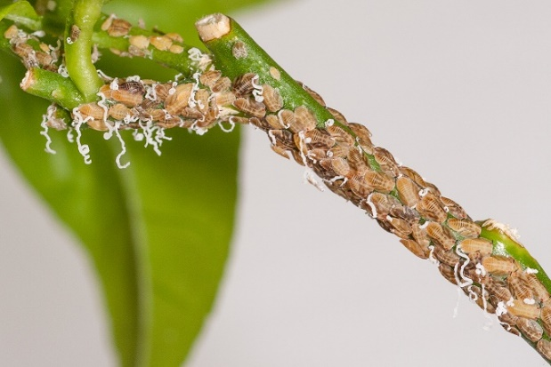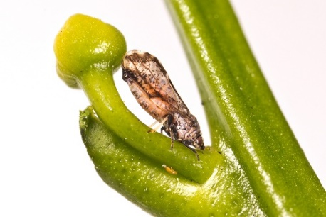

**A**

**B**

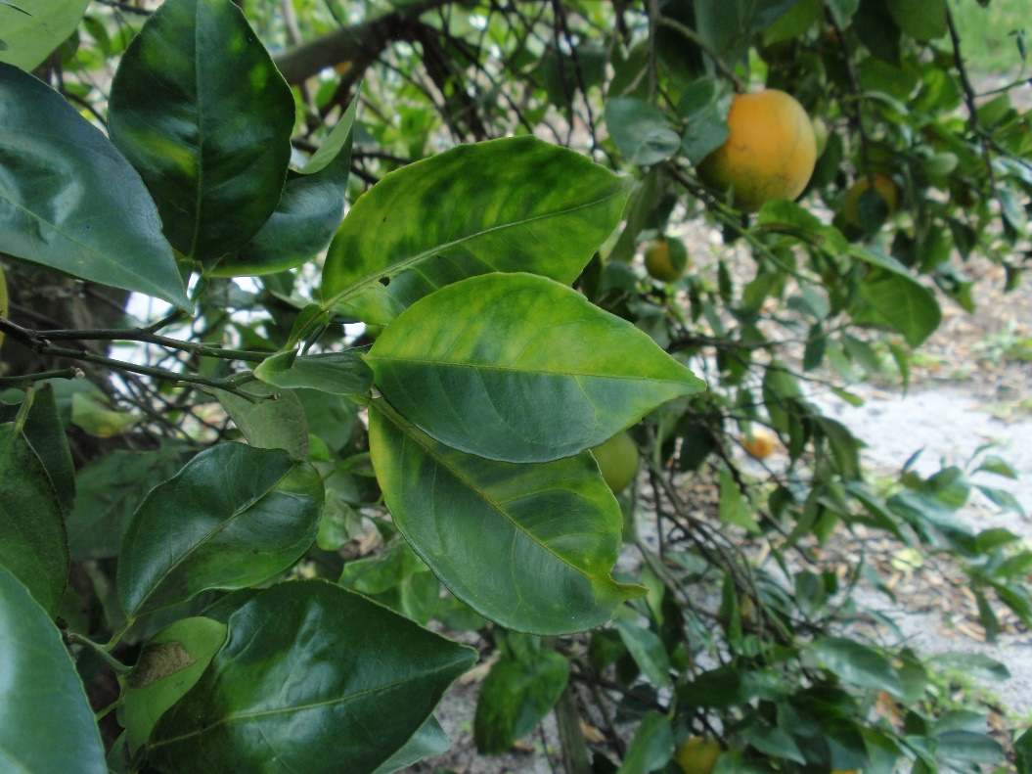

**2**

**Organic Control of Asian Citrus Psyllid is Challenging**

*Nastaran Tofangsazi, Post Doc, Department of Entomology, University of California, Riverside and Beth Grafton-Cardwell, IPM Specialist with the Department of Entomology, University of California Riverside and Director of Lindcove Research and Extension Center*

With the detection of Huanglongbing (HLB) in California in 2012 and 22 additional cases reported during 2015 through June 2016 there is a major concern among citrus growers about the spread of this incurable bacterial disease. The vector of the disease, the Asian citrus psyllid (ACP), is a hardy insect with good dispersal capabilities and can be found in many southern California citrus groves today. With no direct cure for HLB at present, the only option for growers to combat the disease is to control the psyllid. This can prove difficult for conventional citrus growers with broad spectrum insecticides, but for organic citrus growers, which grow an estimated 7% of citrus in California, the task is even more difficult with the currently available options.

Entrust (spinosad) + oil, Pyganic (pyrethrin) + oil, and oil alone are currently the recommended and most widely used insecticide options for organic growers (UC IPM Guidelines for Citrus). While these insecticides are fairly effective in killing ACP if they make direct contact, the residual life of these pesticides is very short (days) compared to conventional insecticides (weeks to months). For example, in our petri dish studies, 10 fl oz/acre Entrust SC + 0.25% Omni supreme spray oil caused 89% mortality, 17 fl oz/acre Pyganic 5.0 EC + 0.25% Omni supreme spray oil caused 73% mortality and 0.25% Omni supreme spray oil caused 42% mortality when 1st-2nd ACP nymphs were exposed to treated leaves one day after application. Nymphal mortality continued to decline for the Entrust + oil treatment (69% mortality) and even more severely declined for Pyganic + oil (27% mortality) 3 days after treatment. In contrast, one-day-old residues of a conventional insecticide, the neonicotinoid 5.5 oz Actara (thiamethoxam), resulted in more than 95% mortality of nymphs and mortality remained high for more than a month.

Studies of grower orchard treatments confirmed laboratory studies that showed a short residual effect of organic treatments (Entrust + oil and oil alone) compared to conventional insecticides (Actara). We monitored changes in population densities of ACP (adults by tap, nymphs and eggs by flush examinations) in the fall of 2015 before and after a grower sprayed separate orchards with one of three insecticides; 1) 1.25% 440 Supreme Spray Oil by ground application (400 gpa), or 2) 9 fl oz Entrust SC + 1% oil by air (50 gpa), or 3) 5.5 oz Actara by air (50 gpa). The oil treatment had little effect on the adult population, but significantly reduced psyllid nymph densities for 17-24 days. Entrust was completely ineffective in controlling psyllid nymphs, but suppressed adult and egg populations for about 14 days. Actara, a conventional insecticide, was the most effective treatment in the study and provided more than 5 weeks of both adult and nymph control. Because of the short residual effect of organic insecticides in citrus, repeat treatments are needed at a frequency of about every 2 weeks for ACP control.

*Tamarixia radiata* wasps released for biological control of ACP provide 20% to 88% parasitism depending on geographical location and time of year. If there were no disease to be concerned about, this level of parasitism by *Tamarixia* would be sufficient to protect citrus from the feeding damage of the psyllid. However, the disease spreads rapidly with just a few psyllids and so a greater level of control is needed. Generalist predators, such as lady beetles, lacewings and assassin bugs, also assist with control. Argentine ants can severely disrupt this parasitism by protecting psyllids from natural enemies. Unhappily, Entrust + oil, thought of as a very selective insecticide combination, was found to be highly toxic to adult *Tamarixia* wasps exposed to 3 day old residues. Thus, the organic insecticide that is the best for controlling the psyllid pest is not compatible with the parasitoid natural enemy, limiting our ability to use integrated strategies to control the psyllid.

At present, it is not mandatory, but is strongly recommended, that all southern California citrus growers treat their orchards in an area wide manner. The area wide program consists of coordinated treatments twice a year (winter and fall), and additional treatments in between. Due to the short residual nature of organic insecticides, organic applications should be applied twice within 10-14 days of each other for every single conventional insecticide application. This is especially important for younger groves as ACP nymphs thrive in new flush. Organic growers have a tough decision to make between treating frequently for ACP and the high cost associated with those treatments or transitioning into conventional management in order to more effectively control ACP. Additional solutions are needed for organic citrus.

UC IPM Guidelines for Citrus: Asian Citrus Psyllid. <http://ipm.ucanr.edu/PMG/r107304411.html>

**Citrus Clonal Protection Program (CCPP) and National Clean Plant Network (NCPN): A Model System for Management of Citrus Diseases**

*Georgios Vidalakis, Department of Plant Pathology and Microbiology, University of California, Riverside, CA 92521-0122, USA. and Greg W. Douhan University of California Cooperative Extension, Tulare County, Tulare, CA 93274-9537*

The Citrus Clonal Protection Program (CCPP) has its roots in the 1930s, when Professor H. Fawcett of the University of California (UC), Citrus Experiment Station in Riverside, discovered the graft-transmissible and viral nature of the citrus psorosis disease. In 1956, following a request from the California citrus industry, UC Riverside established the “Citrus Variety Improvement Program” which in 1977 became the CCPP. Today, the CCPP stands as a cooperative program between the United States Department of Agriculture (USDA), the California Department of Food and Agriculture, and the citrus industry of California as represented by the California Citrus Nursery Board and the Citrus Research Board.

Since 2009, the CCPP has also been part of the National Clean Plant Network (NCPN) for specialty crops. The purpose of the CCPP is to provide a safe mechanism for the introduction into California of citrus varieties from any citrus-growing area of the world for research, variety improvement, or for use by the commercial industry of the state or any citrus hobbyist and enthusiast. This comprehensive mechanism includes disease diagnosis and pathogen elimination, followed by maintenance and distribution of true-to-type citrus propagative material. The potential problems resulting from the introduction of pathogens into a country or citrus area cannot be overemphasized. Likewise the need for pathogen-tested citrus propagative materials is recognized as basic to the establishment and maintenance of a sustainable and profitable citrus industry. The presence of graft-transmissible pathogens such as viruses, viroids or bacteria in citrus propagative materials can be deleterious to tree survival and fruit production for both existing and future citrus plantings.

Realizing that the availability of pathogen-tested, true-to-type propagative materials are critical for citrus and other vegetatively propagated crops, three USDA agencies (Animal and Plant Health Inspection Service, Agricultural Research Service, and National Institute for Food and Agriculture) came to an understanding in 2005 to create a national network to support the use of clean propagative materials. The NCPN, came into being in 2008 with the mission of "providing high quality asexually propagated plant material free of target plant pathogens and pests that cause economic loss.”

Incorporation of citrus into the NCPN began in 2007 and a charter was adopted in March, 2010 for a "Citrus Clean Plant Network" (CCPN). The CCPN currently has centers in California, Florida, Arizona, Texas, Louisiana, Alabama, Hawaii, Maryland, and Puerto Rico. In a typical year, NCPN Citrus centers conduct over 75,000 diagnostic tests, distribute over 600,000 pathogen-tested plant materials, perform therapeutics on hundreds of plants, and maintain hundreds of foundation plants.

NCPN Citrus has established and enhanced quarantine, germplasm, and extension and education programs in all of the major and minor citrus producing regions. This has facilitated the importation, testing, therapy, and release of pathogen-tested citrus to nurseries, growers, and the public both regionally and globally.

**Discouraging citrus varieties smuggling by offering easy access to pathogen-tested budwood**

Rock Christiano, Citrus Clonal Protection Program, Lindcove Research & Extension Center, University of California, 22963 Carson Avenue, Exeter, CA  93221

When I started working at the Citrus Clonal Protection Program (CCPP) in 2012 (Fig. 1), citrus budwood was distributed three times per year (i.e. January, June and September) and there was a minimum order limit for 36 buds per order. In July of 2013, CCPP began monthly budwood distribution and essentially removed the budwood order limit offering as little as one budstick (6 buds). This was a game changer. In the following three years of monthly budwood distribution, the amount of requested buds has increased by almost 90% (Fig. 2), and most importantly, the orders placed by citrus hobbyists has increased by almost 370%. Citrus hobbyists are growing citrus for non-commercial purposes. Many of the hobbyists have a small “citrus forest” in their backyards, typically of diverse varieties, and they are very proud of their trees. They are typically not interested in purchasing grafted citrus trees, they want to graft their own citrus trees. It is hard to understand the citrus hobbyists’ deep affection for their trees! I grew up in a citrus family farm and for me, citrus was as any other crop, a plant for profit. However, after interacting with the citrus hobbyists over the past several years, I have gained a level of respect and understanding that the passion citrus enthusiast have.

I had always been taught that citrus hobbyists are a threat to the citrus industry and their capacity to propagate citrus should be limited or denied. This line of thinking has resulted in some citrus production areas to restrict citrus budwood access for non-commercial use. Today, I see that ignorance is the true threat to the citrus industry. People usually don’t understand or comprehend that smuggling plants or plant parts can disseminate diseases and cause severe economic damage to the farmers. Restricting the desire to propagate a citrus variety may force someone to smuggle it. A sad example is Huanglongbing (HLB) in California. This imminent threat to the California citrus industry was first found in a back yard citrus tree that had 23 grafts of unknown budwood origin.

The California HLB/Asian Citrus Psyllid prevention campaign is doing an excellent job of educating the public. Also the University of California Cooperative Extension is teaching Master Gardeners about the dangers of smuggling plants. On the Internet, there are individuals, such as the pomologist-writer “Fruit Detective” and the citrus hobbyist-blogger “Fruitmentor”, educating people on the correct way to propagate citrus and providing information regarding the threat of importing budwood that that may contain pathogens that could effects citrus production locally. Thanks to this multi educational effort, many citrus hobbyists are now part of the solution and they are actively engaged in the effort to protect the California citrus.

CCPP has over 300 citrus varieties available to anyone interested in propagating citrus trees for commercial or personal use. Orders can be as small as 6 buds (one budstick) per variety at $ 4.50. Therefore, the CCPP offers the incentive to use inexpensive-easily purchased- tested budwood over smuggled or exchanged “dirty” citrus budwood.

Despite all of the above, I still strongly recommend to purchase grafted trees at local stores or online (e.g.

[www.fourwindsgrowers.com](http://www.fourwindsgrowers.com)). Grafting citrus is not as easy as it may look. It requires skill, another citrus tree to be used as a rootstock, and a controlled environment (especially

temperature and water). However, if you are going to do it yourself, make sure the material your using is disease free!

To learn more about the CCPP, go to [www.ccpp.ucr.edu](http://www.ccpp.ucr.edu) and remember: CCPP is the place for starting citrus correctly.

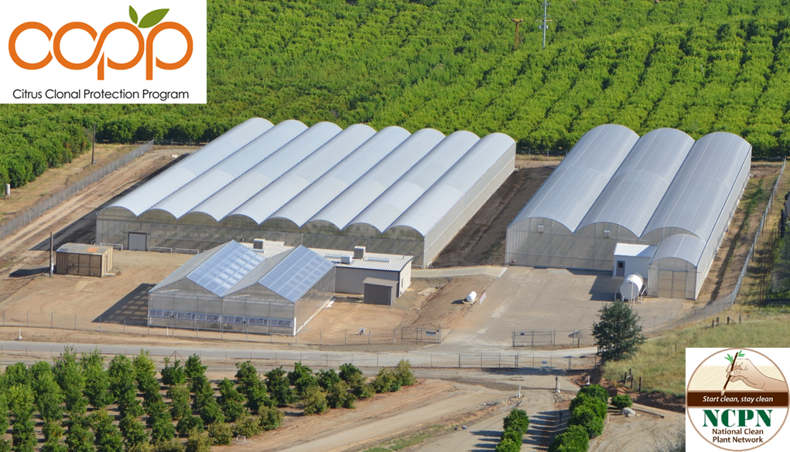

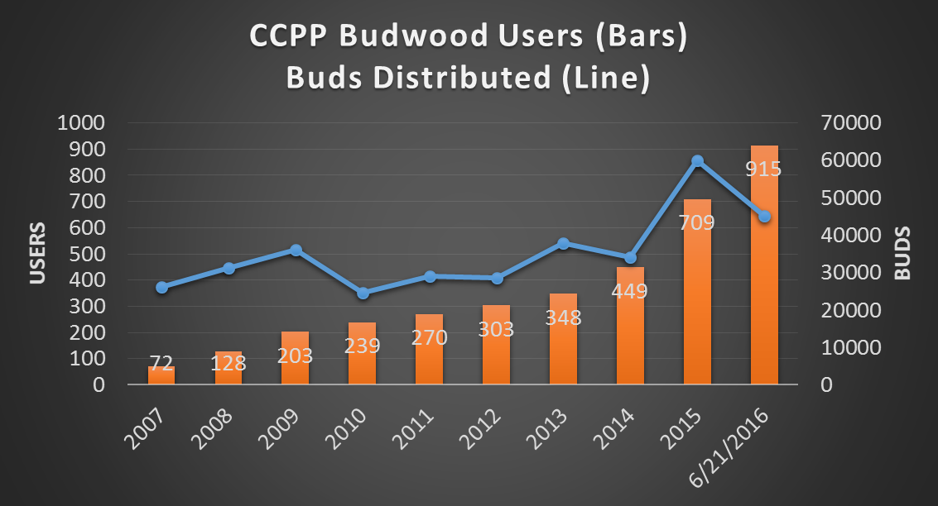**Figure 1** Panoramic view of the Citrus Clonal Protection Program foundation block operations at the Lindcove Research and Extension Center, Exeter, California. Photo: E. Grafton-Cardwell.

**Figure 2** Amount of the Citrus Clonal Protection Program (CCPP) online budwood ordering system users and budwood distribution. Note: from 2007 to June of 2013, budwood was distributed three times per year (January, June, and September) and there was a minimum order limit of 36 buds; since July of 2013, budwood has been distributed monthly with a minimum order limit of 6 buds (one budstick).

**Nonprofit Org**

**US Postage Paid**

**Visalia, CA 93277**

**Permit No. 240**

**Cooperative Extension**

**University of California**

**4437B S Laspina St**

**Tulare, CA 93274**

Topics in Subtropics



Greg Douhan

Farm Advisor

**Upcoming Meetings and Programs:**

Wednesday, July 13, 2016 – Joint Citrus & CPDPC Meetings – 7:30 AM Registration Starts

Location: Tulare County Agricultural Building, 4437 S. Laspina St., Tulare, CA

More information available at: http://cetulare.ucanr.edu/newletters_898819/Citrus_Notes_873/

*The University of California, Division of Agriculture and Natural Resources (UC ANR) prohibits discrimination against or harassment of any person in any of its programs or activities on the basis of race, color, national origin, religion, sex, gender, gender expression, gender identity, pregnancy (which includes pregnancy, childbirth, and medical conditions related to pregnancy or childbirth), physical or mental disability, medical condition (cancer-related or genetic characteristics), genetic information (including family medical history), ancestry, marital status, age, sexual orientation, citizenship, status as a protected veteran or service in the uniformed services (as defined by the Uniformed Services Employment and Reemployment Rights Act of 1994 [USERRA]), as well as state military and naval service. UC ANR policy prohibits retaliation against any employee or person in any of its programs or activities for bringing a complaint of discrimination or harassment. UC ANR policy also prohibits retaliation against a person who assists someone with a complaint of discrimination or harassment, or participates in any manner in an investigation or resolution of a complaint of discrimination or harassment. Retaliation includes threats, intimidation, reprisals, and/or adverse actions related to any of its programs or activities. UC ANR is an Equal Opportunity/Affirmative Action Employer. All qualified applicants will receive consideration for employment and/or participation in any of its programs or activities without regard to race, color, religion, sex, national origin, disability, age or protected veteran status. University policy is intended to be consistent with the provisions of applicable State and Federal laws. Inquiries regarding the University’s equal employment opportunity policies may be directed to: John I. Sims, Affirmative Action Compliance Officer and Title IX Officer, University of California, Agriculture and Natural Resources, 2801 Second Street, Davis, CA 95618, (530) 750-1397. Email:* [*jsims@ucanr.edu*](mailto:jsims@ucanr.edu)*.   
Website:* [*http://ucanr.edu/sites/anrstaff/Diversity/Affirmative_Action/*](http://ucanr.edu/sites/anrstaff/Diversity/Affirmative_Action/)*.*